

**Blood Pressure estimation based on PPG using neural network**

Project Submitted By: Dorin Alon & Shirili Shelef

Project Supervisors: Ron Teichner & Dr. Danny Eitan

**Contents:**

1. Abstract //shirili
2. Introduction:
   1. Motivation //shirili
   2. Project goal //dorin
   3. Medical background //dorin - *(write something about the database?)*
3. The chosen network
   1. Architecture//shirili -only explenation on LSTM
4. Project flow:

a. add whole project blocks diagram

* 1. Synthetic signals //(in short) //dorin – fix to what we really did
  2. Choosing the input signals to the net //shirili – choosing PPG because it’s similar to BP
  3. Block diagram//shirili

1. Results:
   1. Creation and optimization of the net //dorin
   2. Training on a single patient and predicting BP of the same patient//shirili
   3. Training on a single patient and predicting BP of different patients//shirili
2. Conclusion:
   1. Discussion *//algorithm and problems-* *normalization data , clips position, various train*
   2. Future works
3. Appendix:
   1. Pictures from synthetic signals
   2. Code and user instructions
   3. Output tables (train and test)
4. References

**1. Abstract**

Blood pressure (BP) is a significant vital that is monitored for every patient in intensive care, and could indicate cardiovascular status. Nowadays, BP is measured throughout an invasive manner - catheter directly into an artery.

This form of measurement is not convenient for the patient, and could lead an infection. Photopletysmogram (PPG) is a signal measured in a non invasive manner – a clips on the patient's finger. In this project, we will suggest a way to estimate BP based using neural network (NN) type LSTM.

**2. Introduction**

**2.1 - motivation:**

Critically ill patients are monitored continuously with vital physiologic signals. The medical team need to be in control over the patient signals, specifically blood pressure (BP). The way to measure this vital is a catheter into an artery, this way the signal can be presented continuously on a monitor. Another way to measure BP is with a cuff on a patient's limb, but the measurement is taken periodically, and the result is inaccurate enough and not continuously. Therefore the patient BP will be monitored in an invasive way, which can lead to an infection and thrombosis (clot).

There is no direct formula which connect BP values to other vitals that are measured in non-invasive ways, such as electrocardiogram (ECG), respiratory impedance (RI), and PPG. Nevertheless, the connection between the signals exists, so artificial intelligence was required to figure out the connection. In this project we will present the neural network we used to estimate BP using PPG.

*הסבר על חשיבותו של לחץ הדם עבור מטופלים, למה אין דרך אחרת חוץ מהקטטר, ולמה בחרנו ברשת נוירונים שתלמד את המטופל.*

**2.2 – project goal:**

As mentioned in the motivation above, a patient's blood pressure is measured in a very invasive way. The goal of this project is to estimate a patient's blood pressure by means of deep learning methods, functioning on non-invasive continuously measured vitals, such as ECG, RI and PPG. By that, it is possible to avoid BP measuring at all, or to measure it for a short period of time. The estimation is required to be quite accurate, and predict BP elevation or descent, since it can indicate a patient's status, and alert the medical crew before an emergency.

**2.3 – medical background**

* hospital A,

* not normalized signals

* BP conversion formula

* explain on every signals

* sampling rates

**3. The chosen network**

Long Short-term memory (LSTM) is an artificial Recurrent neural network (RNN) architecture that can process an entire sequence of data, and not a single point. This quality of memory of the past is necessary in order to learn a patient's behavior. The downside of LSTM is process unit, so we worked on the GPU of the lab.

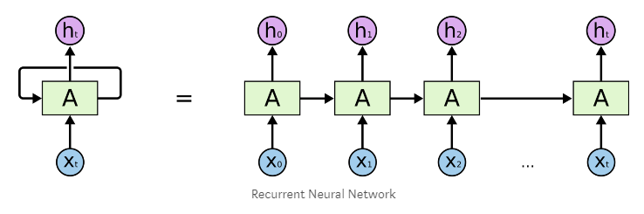

**3.1 - Architecture:**

At first we tried a straight forward approach – 1 big vector of 10 minute train set. We performed many trials for the network features – we changed the number of layers, number of hidden layers, amount of iterations, and step size. Some produced better results than other, but the whole process of train took a lot of time – more than 1 hour for 10 minute train set.

In order to take advantage of the qualities of GPU and shorten the train process - we tried a parallel approach.

After several trials, we decided to perform the train procedure with 2**16 samples, which are equivalent to approximately 9 minutes. We divided this train set to batches of 16 seconds, which means 32 batches. This way we reached improvement by 32 time than without batches (without batches means the whole train set in one vector). From one hand, using GPU can reach 2500 train iterations in 10 minutes, from the other hand, the memory of the LSTM is only 16 seconds.

The final parameters:

|  |  |  |  |
| --- | --- | --- | --- |
| **Layers** | **Hidden size** | **Step size** | **Iterations** |
| 2 | 12 | 1e-3 | 2500-3500 |

**4. Project flow**

**4.1 – synthetic signals:**

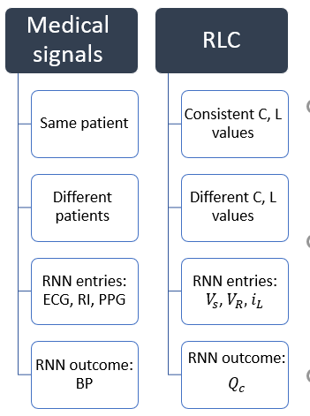In order to ensure that our neural network is working, we performed a sanity check. We created four types of synthetic signals that simulates an electric circuit. Since it is a well-known problem, it has a scientific solution that is composed of a differential equation. The four signals are source voltage, resistor voltage, inductor current and capacitor charge. We especially chose the synthetic signals so that they will be somehow equivalent to our medical signals, and this experiment will simulate the medical situation. Bellow, the analogy between the synthetic and the medical signals:   
  
C- capacitor's capacity

L-

the relation between the four signals is as shown:

insert the equation

bellow, our network prediction of the capacitor’s charge given different input signals:

insert results

**4.2 - Choosing the input signals to the net:**

The most similar vital to BP is PPG – they are sampled in the same ratio, they seems to have similar cyclic *(periodic מחזורי)*  behavior, and medically it makes sense to research their correlation –

במחזור הדם- כל פעימה חדשה מזרימה עוד דם מחומצן , כך שבעליה של לחץ הדם יעלה גם רוויון החמצן בו.

Moreover, we performed several trials for estimation BP based on all the signals in the database: PPG, RI, ECG. Those trials were made before the batches optimization that was done for the NN, which means 3 input to the NN, each contains vector of train data. As a result, the NN could not estimate BP in a good way – the estimation was pretty bad. For comparison, the same NN that got only PPG for the same features estimated pretty well the BP of the patient.

All of the above led us to use the PPG vital as the only input to the NN.

//להוסיף תמונות מהשערוך של כל הסיגנלים

After we were done optimizing the NN, we had to choose patient to work with. The input segments were chosen carefully:

- BP segments has to be various enough (include increasing and decreasing of BP).

- both BP and PPG segments should be proper measured and without nois. Our data base is raw and the signals come from critically-ill patients, so the data can contains exceptions and picks that can confuse our NN.

- we tried to choose a patient that was recorded long enough, so we could test the trained NN for different periods of time after the train period //2 hours after the train, 5 hours, 22 hours….

**4.3 – block diagram:**

In the following diagrams we will show the signal flow from the database to the BP estimation:

**Train and test on the same patient:**

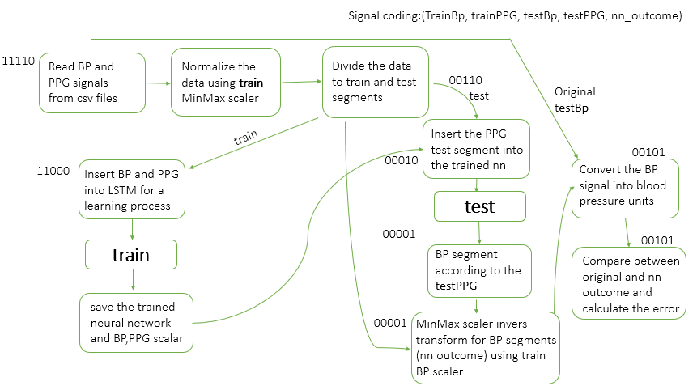

**Train on one patient and test on another:**

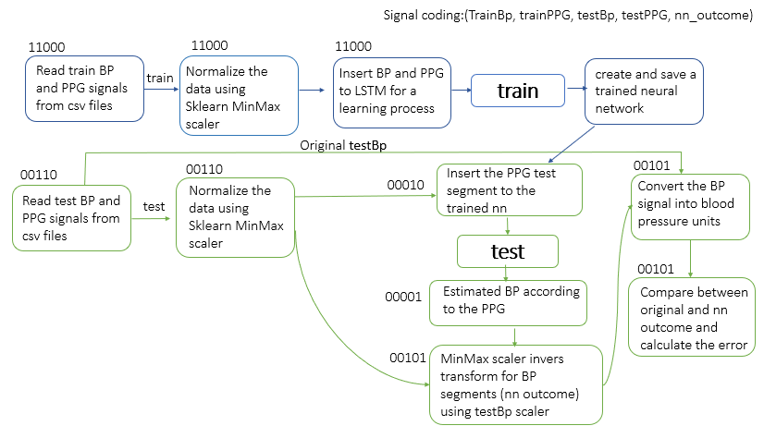

**5. Results**

**6.1 - Creation and optimization of the net:**  
hidden layers and all- try different values and show results.

GPU batches- faster- explain why

**6.2 - Training on a single patient and predicting BP of the same patient**

We succeeded in learning a patient and conclude about future times (of the certain patient). We took a train set that was various enough, we made sure that the BP segment contained increasing and decreasing in BP values.//אולי זה מתאים לסעיף 5.2

With 10 minute of train segment, the NN succeed in estimating future BP based on PPG segment.

//לבחור את המטופל שרוצים להציג

We can see that in the next few hours the NN estimates values that are close to the expected BP.

We assume that the faults in the estimation are due to changes in PPG segment. The patient's physiology hasn’t changes, so the change can arise from the way the clips is suited on the patient's hand.

//PPG photos

**6.3 - Training on a single patient and predicting BP of different patients**

//לבחור את המטופל שרוצים להציג

We examined a NN that was trained on a certain patient (10 minute various segment) – perform an estimation for another patient. The data normalization has been done with the test segment.

**6. Conclusion**

//problems: - normalization, various data, changing PPG (could be clips, could be medications or physical condition of the patient)

algorithm:

future works: